Experimental setup: Convection and Heat Transfer in Tubes
  - Major Innovation Project Functional Skin / Façade Cooling Panel

Testing schedule

Date |  | What to do? | What do we need?
Mon | 06-jul | Conduct negative control and finalize test setup
Tue | 07-jul | Testing with thickness #1 | Using Marcel de Reeder's halogeenlamp and room at Kruyt 4th floor
Wed | 08-jul | Testing with thickness #2
Thu | 09-jul | Testing with thickness #3
Fri | 10-jul | Testing with large tube
Sat | 11-jul
Sun | 12-jul
Mon | 13-jul | Analyze results, construct and paint new tubes
Tue | 14-jul | Testing with Radiative cooling coating
Wed | 15-jul | Testing with white high albedo paint
Thu | 16-jul | Testing with retro-reflective beads
Fri | 17-jul

Objective and principles of the experiment
The objective of this experiment was to evaluate the thermal performance of a ventilated façade system consisting of one rectangular tube shaped chimney, with in it a a ventilated air cavity, and an inner structural plywood layer. The experiment focused on quantifying surface temperatures, cavity air temperatures, and airflow velocities within the cavity under controlled exposure conditions.
The working principle of the façade is based on solar heating of the exterior cladding layer. Absorption of solar radiation increases the surface temperature of the outer façade, which subsequently heats the air inside the ventilated cavity. The resulting temperature gradients are expected to generate buoyancy-driven airflow, in which warm air exits through the upper cavity opening while cooler ambient air is drawn in through the lower opening, thereby creating a natural ventilation and cooling mechanism.
By measuring surface temperatures, cavity air temperatures and cavity airflow, an analysis can me made of how the exterior layer absorbs direct solar radiation and how the resulting temperature differences hypothetically create buoyancy forces. These forces could push warm air out of the top of the facade and draw cooler air through the bottom, creating a natural cooling airstream.

The façade test setup consisted of an outer cladding layer, a ventilated cavity, and an inner plywood wall. Sensors were positioned to measure thermal and airflow conditions at multiple locations throughout the system. Measurements included;
- The exterior surface temperature of the cladding
- The interior surface temperature of the inner wall
- The air temperature at the bottom, middle, and top of the cavity
- The air velocity at the bottom and top of the cavity.
The cavity instrumentation was mounted using bolts attached through threaded inserts mounted in the back wall to ensure stable sensor positioning and minimal obstruction of airflow.

Sensor data logging
Sensor data were collected and logged using an Arduino Uno R4 WiFi microcontroller in combination with a data logger shield. All temperature sensors communicated through the I2C protocol, enabling synchronized acquisition of thermal measurements throughout the experiment. Thermal images acquired using the FLIR A655sc camera were processed separately for qualitative and quantitative thermal analysis of façade surface temperatures.

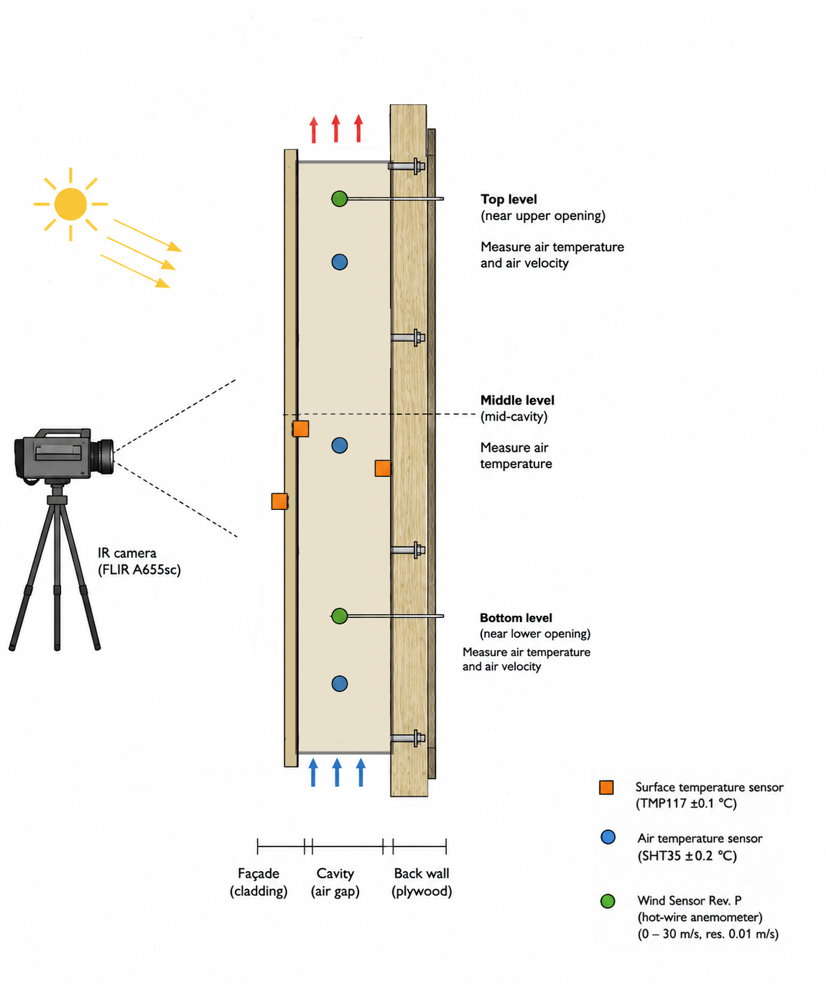
Figure 1: Schematic overview of experimental setup.
Materials and methods

Equipment
A combination of contact sensors, air probes and non-contact thermal imaging equipment is used to measure airflow within the cavity, cavity air temperatures and surface temperatures of the outer façade and the inner layer.

Air temperature measurement
Air temperature within the cavity was measured using SHT45 outdoor temperature and humidity sensors (Adafruit Industries, USA). The sensors provided a measurement accuracy of approximately ±0.1 °C and communicated through an I2C interface connected to an Arduino Uno R4 WiFi microcontroller.

Temperature sensors were positioned at the lower, middle, and upper sections of the ventilated cavity to capture vertical temperature gradients associated with buoyancy-driven airflow (Fig. 1).

In addition, a thermal anemometer (testo 405i, Testo SE & Co. KGaA, Germany) was used to simultaneously measure local air temperature at the airflow measurement location.

Surface temperature measurement and mapping
Surface temperatures of the inner façade components (so not on the outer façade surface) were measured using TMP117 high-accuracy contact temperature sensors (Adafruit Industries, USA) with an accuracy of ±0.1 °C. Sensors were attached directly to the measurement surfaces to ensure proper thermal contact. Measurements were performed on both the inner cladding surface and the inner plywood wall surface.
For spatial thermal mapping of the façade exterior, a FLIR A655sc infrared camera (FLIR Systems, USA) was used. The camera features a thermal sensitivity (NETD) below 30 mK, enabling detection of small temperature differences across the façade surface. Infrared thermography was used to visualize surface temperature distributions and identify localized thermal variations during testing.

Airflow velocity measurements
Airflow velocity within the ventilated cavity was measured using a hot-wire thermal anemometer sensors (Modern Device Wind Sensor Rev. P, USA). The Wind Sensor Rev. P is a hot-wire anemometer incorporating ambient temperature compensation through positive temperature coefficient (PTC) thermistors. The sensor can measure wind velocities ranging from 0 to 67 m*s^{-.1}. The sensor allows direct interfacing with low-voltage microcontroller systems such as the Arduino Uno R4 WiFi used in this study. The sensor design additionally reduces directional sensitivity and improves measurement stability. Velocity measurements were conducted near the lower and upper cavity openings to assess the magnitude and direction of buoyancy-induced airflow through the façade system.

The experimental measurements were combined with a dynamic energy and exergy analysis methodology adapted from Picallo-Perez et al. Sensor data were used to quantify transient heat storage, heat transfer, and airflow-related energy transport within the ventilated façade.
Air temperature gradients temperature gradient

Internal energy accumulation
The rate of change of internal energy stored within the façade was calculated as:
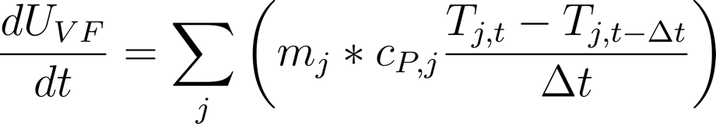
(1)
Where m_{j} and c_{P,j} are the mass and specific heat capacity of layer (j), respectively, and T_{j} is the measured layer temperature. Layer temperatures were obtained from the TMP117 sensors for the internal surfaces, the FLIR A655sc camera for the external façade surface, and the SHT45 sensors for cavity air temperatures. Material properties were determined from manufacturer specifications and measured dimensions.
Sources : (Incropera’s Principles of Heat and Mass Transfer, Global Edition, 8th Edition | Wiley, n.d.)

ASHRAE handbook

Air enthalpy transport
The heat removed by natural ventilation within the cavity was determined from the enthalpy difference between inlet and outlet air streams:

(2)
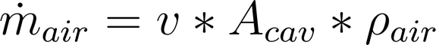
where T_{in} and T_{out} are the air temperatures measured at the lower and upper cavity openings, respectively. The air mass flow rate ṁ_{air} was calculated as:
(3)
where (v) is the measured air velocity obtained from the hot-wire anemometers, A_{cav} is the cavity cross-sectional area, and ρ_{air} is the air density.

Newtons law of cooling:
- Heat transfer coefficient; convection heat coefficient; can it be determined from the conductivity of the plywood?

Bronnen:

Moran, M. J., Shapiro, H. N., Boettner, D. D., & Bailey, M. B. (2010). Fundamentals of engineering thermodynamics (7th ed.). John Wiley & Sons.
Fluid dynamics, F.M. White

Internal and External Heat Transfer
Heat exchange between the façade and its surroundings was evaluated using combined convection-radiation heat transfer relationships

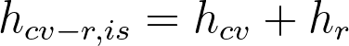

h = k / Δx , waarbij Δx dikte van plywood is.
k = W / (m * K)

Volgens de Wet van Fourier kom je dan op;
For the internal surface:

T_{i} is de lucht temp binnenkant koker (SHT45 gemiddeld)
T_{is} is de surface temp binnenkant koker (TMP117)

where T_{i} is the indoor air temperature, T_{is} is the internal surface temperature measured by the TMP117 sensors, A is the façade area, and h_{cv-r,is} is the combined internal convection-radiation heat transfer coefficient.
For the external surface:


where T_{e} is the external surface temperature obtained from infrared thermography, T_{eq} is the equivalent outdoor temperature, and h_{cv-r,es} is the external combined heat transfer coefficient. is the façade surface area.
Te is de “external” surface temperature, TMP117
Teq is de equivalent outdoor temperatuur. Dus de kamer temperatuur, meten met picologger of testio (achter het panel).

Source: (Picallo-Perez & Sala-Lizarraga, 2023)
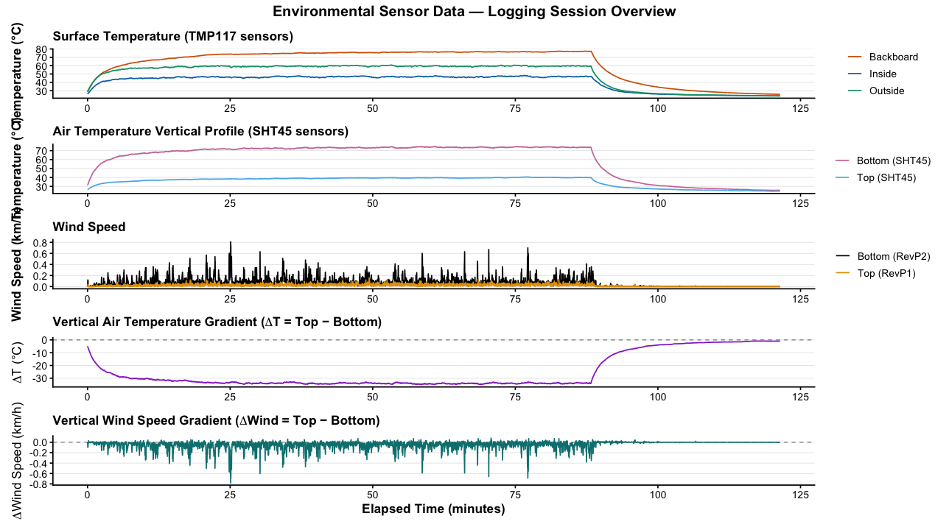

Appendix A1: Arduino script (C++).
#include <Adafruit_Sensor.h>
#include <Adafruit_TMP117.h>
#include <Adafruit_SHT4x.h>
#include <Wire.h>
#include <SPI.h>
#include <SD.h>
#include <math.h>

#define TCAADDR 0x70

const int chipSelect = 10;

// RevP1
const int RevP1_WindPin = A0;
const int RevP1_TempPin = A2;

// RevP2
const int RevP2_WindPin = A1;
const int RevP2_TempPin = A3; // NIET A5 gebruiken, want A5 = I2C SCL

Adafruit_TMP117 Surface_Temp_Backboard;
Adafruit_TMP117 Surface_Temp_Inside;
Adafruit_TMP117 Surface_Temp_Outside;

Adafruit_SHT4x Air_Bottom;
Adafruit_SHT4x Air_Top;

void tcaSelect(uint8_t channel) {
if (channel > 7) return;
Wire.beginTransmission(TCAADDR);
Wire.write(1 << channel);
Wire.endTransmission();
}

float readWindKmh(int pin) {
int windADunits = analogRead(pin);

if (windADunits <= 264) return 0.0;

float windMPH = pow((((float)windADunits - 264.0) / 85.6814), 3.36814);
return windMPH * 1.60934;
}

float readRevPTempC(int pin) {
int tempRawAD = analogRead(pin);
return ((((float)tempRawAD * 5.0) / 1024.0) - 0.400) / 0.0195;
}

void setup() {
Serial.begin(115200);
while (!Serial) delay(10);

Wire.begin();

if (!SD.begin(chipSelect)) {
Serial.println("SD kaart niet gevonden!");
while (1);
}

File logfile = SD.open("datalog.csv", FILE_WRITE);
if (logfile) {
if (logfile.size() == 0) {
logfile.println(
"Time_ms,"
"Surface_Temp_Backboard_C,"
"Surface_Temp_Inside_C,"
"Surface_Temp_Outside_C,"
"Air_Temp_Bottom_C,"
"Air_RH_Bottom,"
"Air_Temp_Top_C,"
"Air_RH_Top,"
"RevP1_Wind_kmh,"
"RevP1_Temp_C,"
"RevP2_Wind_kmh,"
"RevP2_Temp_C"
);
}
logfile.close();
}

tcaSelect(0);
if (!Surface_Temp_Backboard.begin()) {
Serial.println("Surface_Temp_Backboard niet gevonden");
while (1);
}

tcaSelect(1);
if (!Surface_Temp_Inside.begin()) {
Serial.println("Surface_Temp_Inside niet gevonden");
while (1);
}

tcaSelect(3);
if (!Surface_Temp_Outside.begin()) {
Serial.println("Surface_Temp_Outside niet gevonden");
while (1);
}

tcaSelect(6);
if (!Air_Bottom.begin()) {
Serial.println("Air_Bottom SHT niet gevonden");
while (1);
}

tcaSelect(7);
if (!Air_Top.begin()) {
Serial.println("Air_Top SHT niet gevonden");
while (1);
}

Serial.println("Alle sensoren gevonden. Logging gestart.");
}

void loop() {
unsigned long timestamp = millis();

sensors_event_t tmp_event;
sensors_event_t humidity_event;
sensors_event_t sht_temp_event;

float surface_temp_backboard;
float surface_temp_inside;
float surface_temp_outside;

float air_temp_bottom;
float air_rh_bottom;
float air_temp_top;
float air_rh_top;

tcaSelect(0);
while (!Surface_Temp_Backboard.dataReady()) delay(10);
Surface_Temp_Backboard.getEvent(&tmp_event);
surface_temp_backboard = tmp_event.temperature;

tcaSelect(1);
while (!Surface_Temp_Inside.dataReady()) delay(10);
Surface_Temp_Inside.getEvent(&tmp_event);
surface_temp_inside = tmp_event.temperature;

tcaSelect(3);
while (!Surface_Temp_Outside.dataReady()) delay(10);
Surface_Temp_Outside.getEvent(&tmp_event);
surface_temp_outside = tmp_event.temperature;

tcaSelect(6);
Air_Bottom.getEvent(&humidity_event, &sht_temp_event);
air_temp_bottom = sht_temp_event.temperature;
air_rh_bottom = humidity_event.relative_humidity;

tcaSelect(7);
Air_Top.getEvent(&humidity_event, &sht_temp_event);
air_temp_top = sht_temp_event.temperature;
air_rh_top = humidity_event.relative_humidity;

float RevP1_WindKmh = readWindKmh(RevP1_WindPin);
float RevP1_TempC = readRevPTempC(RevP1_TempPin);

float RevP2_WindKmh = readWindKmh(RevP2_WindPin);
float RevP2_TempC = readRevPTempC(RevP2_TempPin);

String dataString =
String(timestamp) + "," +
String(surface_temp_backboard, 2) + "," +
String(surface_temp_inside, 2) + "," +
String(surface_temp_outside, 2) + "," +
String(air_temp_bottom, 2) + "," +
String(air_rh_bottom, 2) + "," +
String(air_temp_top, 2) + "," +
String(air_rh_top, 2) + "," +
String(RevP1_WindKmh, 2) + "," +
String(RevP1_TempC, 2) + "," +
String(RevP2_WindKmh, 2) + "," +
String(RevP2_TempC, 2);

Serial.println(dataString);

File logfile = SD.open("datalog.csv", FILE_WRITE);
if (logfile) {
logfile.println(dataString);
logfile.close();
} else {
Serial.println("Fout bij schrijven naar SD");
}

delay(2000);
}

References

- Picallo-Perez et al.

